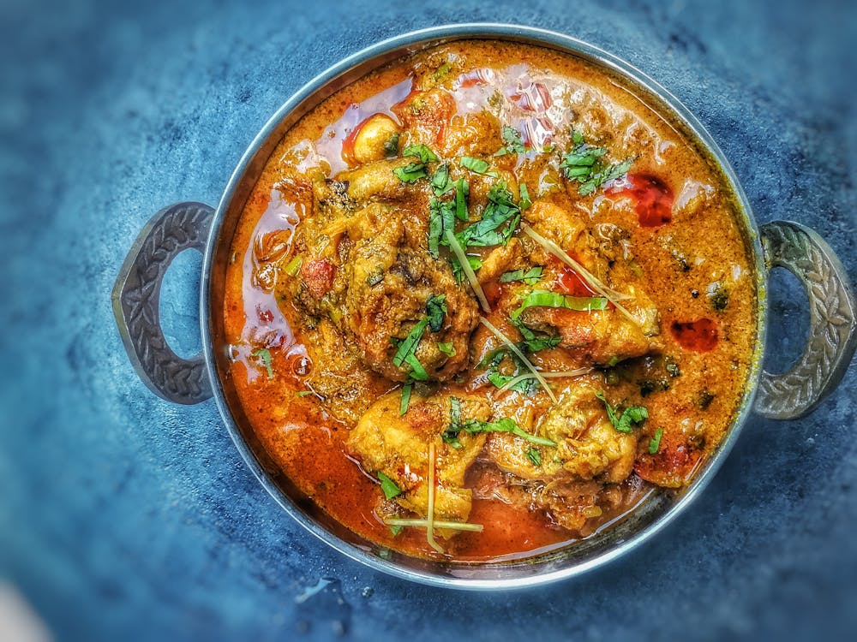
CURRY NIGHT
Friday 28th February 2025
Starter & Main - £18.95

Sharing Starter
Beef Seekh Kebab, Chicken Tikka, Fish Kofta, Athrak Soup, Poppadom & Pickle Tray

Choice Main
Chicken Makhani
Sri Lankan Black Pork Curry
Lamb Shoulder Massaman
Goan Fish Curry
All mains served with garlic & coriander rice, Bombay potatoes and homemade chapati

Desserts
from the fridge from £6

