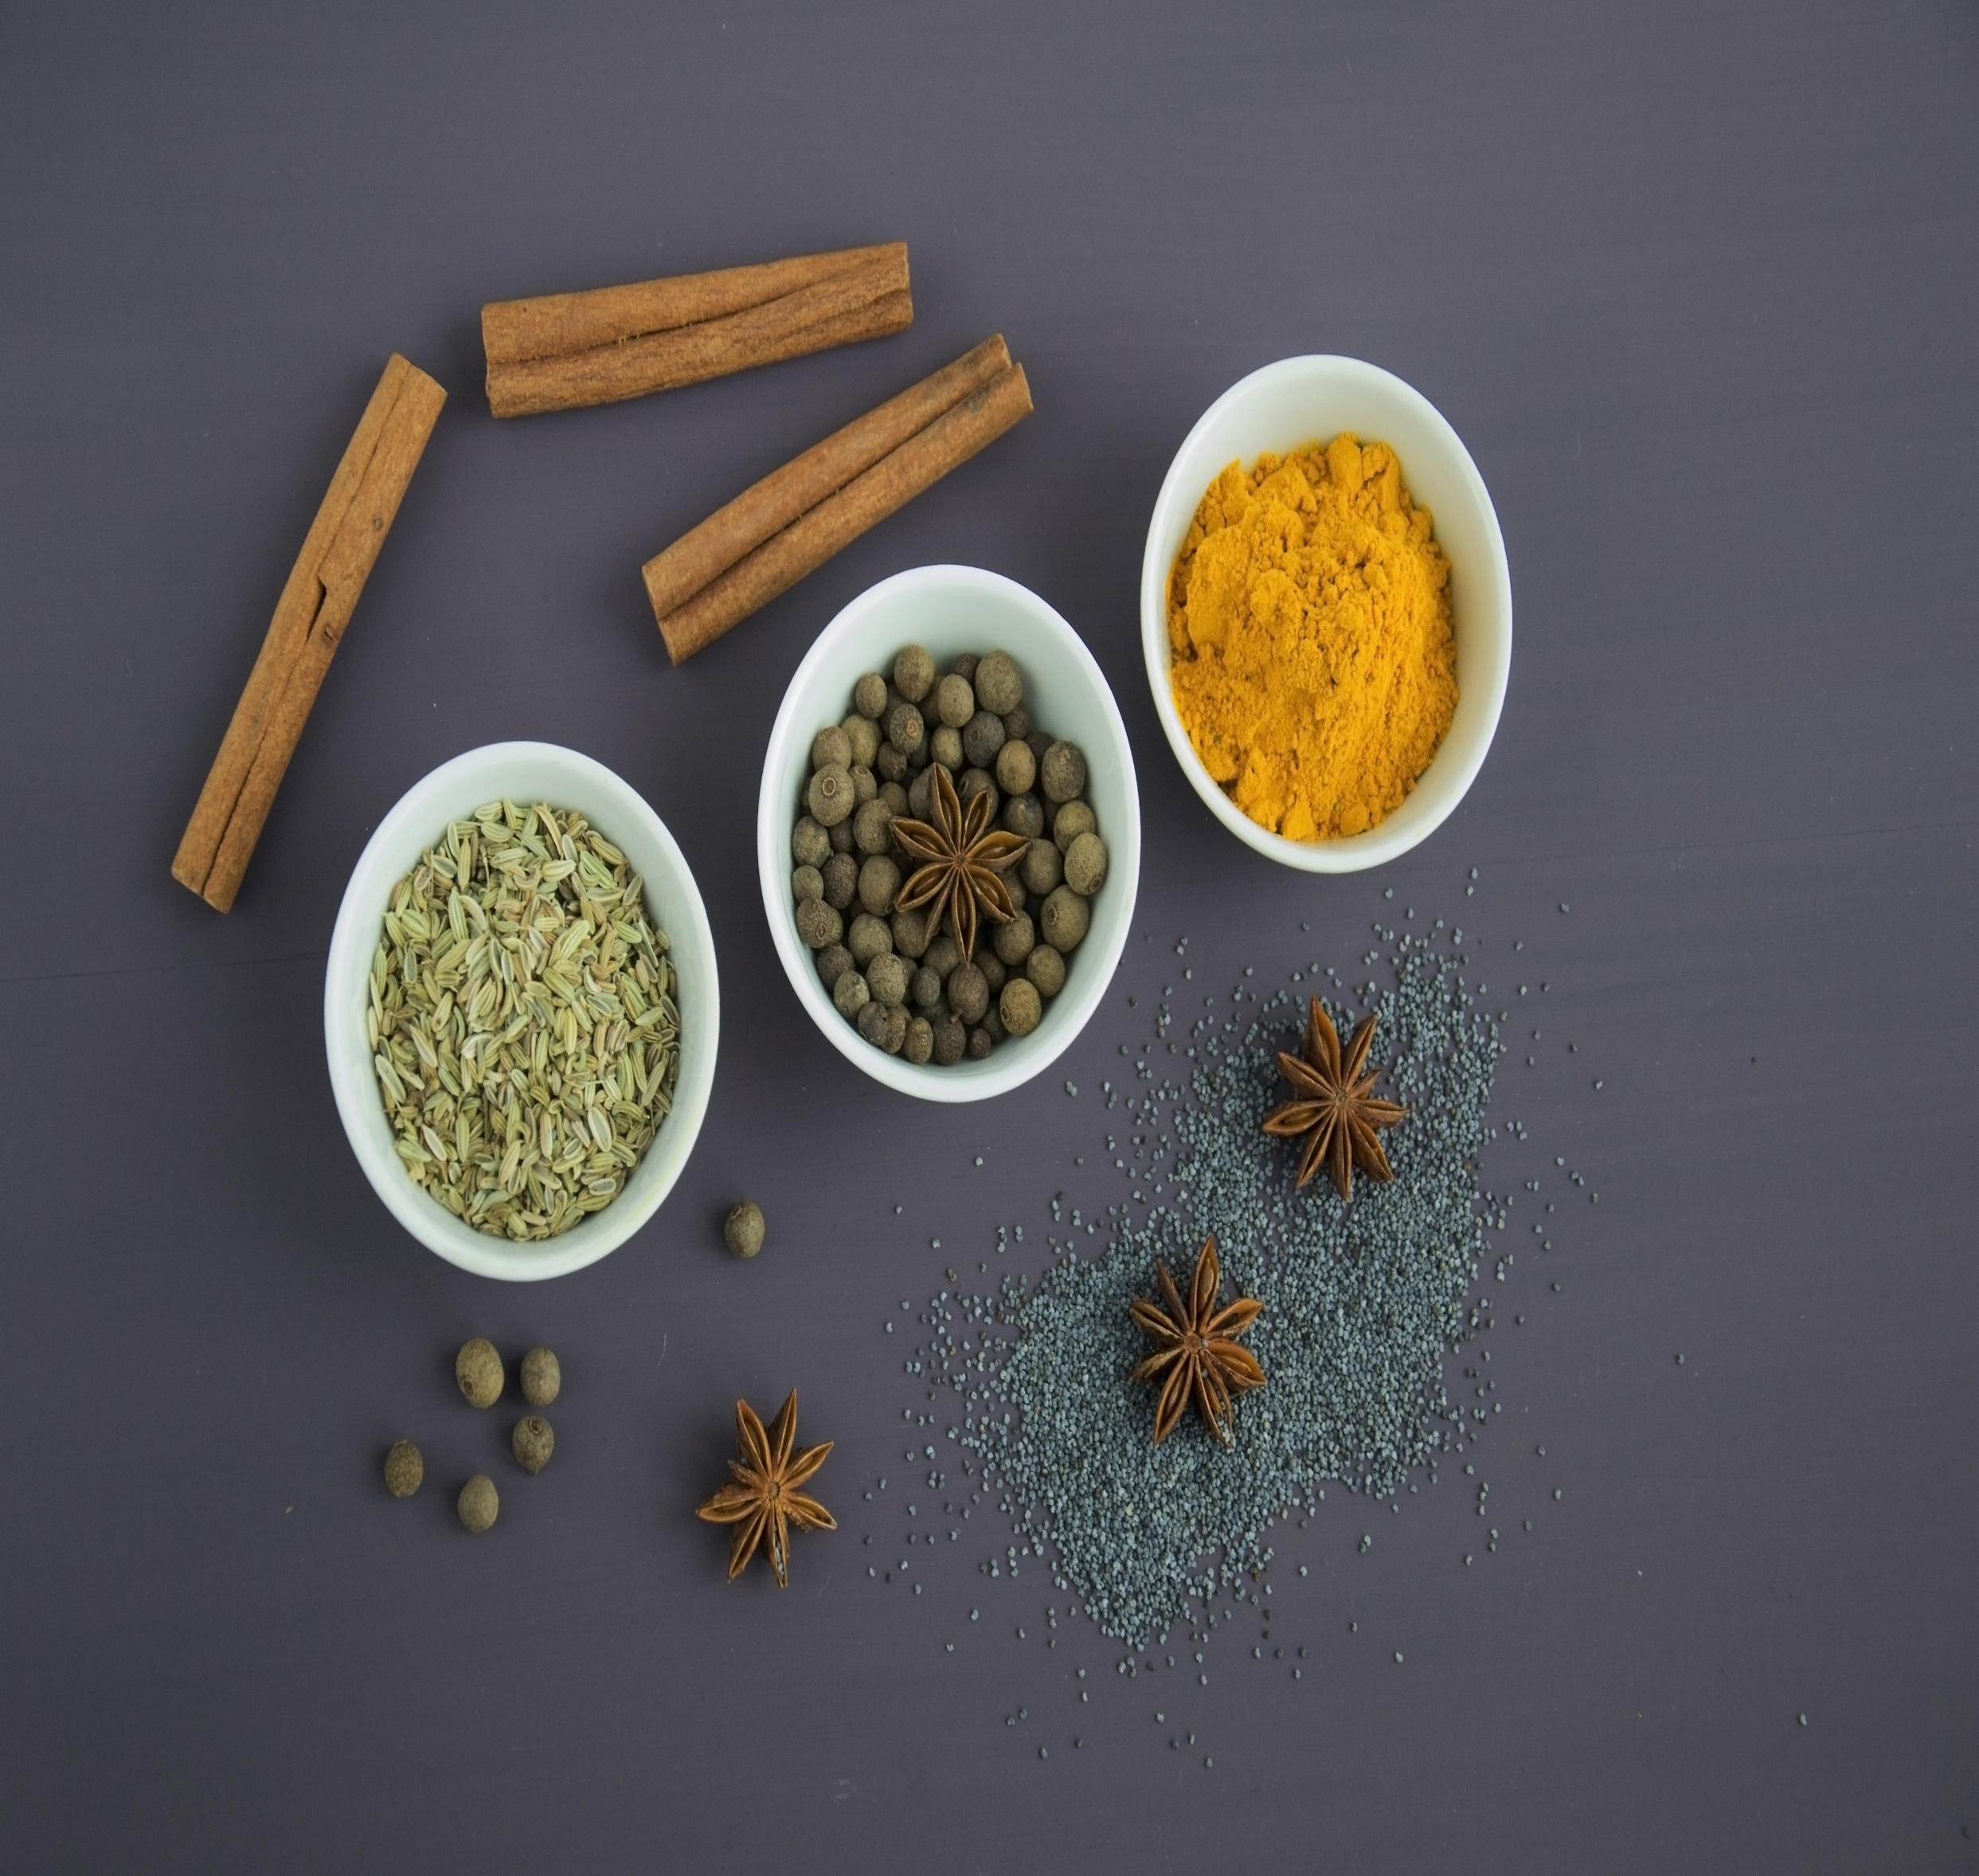

**Asian Themed Menu - £24.95pp**

**January 29th 2025**

**SHARING STARTER**

**Dragon & Phoenix Balls, Bang Bang Salmon Bites, Hot & Sour Soup, Yuk Sung, Tandoori Chicken Naan Buns**

**CHOICE MAIN**

**Chinese Brisket Noodle Soup**

**Thai Red Chicken Curry**

**Prawn Stir Fry**

**Sticky Belly Pork**

**To share – Egg Fried Rice, Soy Marinated Eggs, Aloo Gobi, Prawn Crackers**

**DESSERT SHARE PLATTER**

**Japanese Cheesecake, Mango Mochi Ice Cream, Sesame & Ginger Rice Cakes, Dalgona Candy, Matcha & White Chocolate Cupcakes**